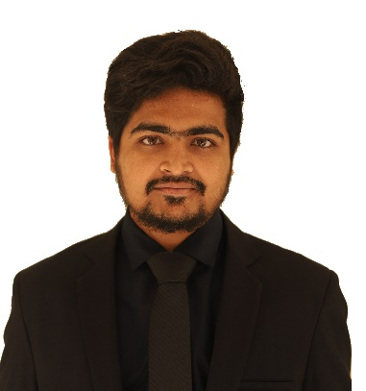

**Md. Imran Hossain**

**Village :** Laksmipur **P.O :** Konnadah **P.S :** Harinakundu **Dist :** Jhenaidah

**Mobile** : 01728603351

**Email** : mdimran1409036@gmail.com

|  |  |
| --- | --- |
| Career Objectives | As a Communication and Network Engineer, My goal is to build a successful career which enables me to work with communication and information technology, different network infrastructures and troubleshoot the upcoming issues as well. |
| Skills | * Good understanding of **OSI Model**, **TCP/IP protocol suite** (IP, ARP, ICMP, TCP, UDP, SMTP, FTP) * Configuring and Troubleshooting of Networking Equipments: **Routers and Switches**. * Basic knowledge of **VoIP,VLAN, TDM, NAT, DNS and Proxy Server, ERP, DHCP, Antenna, microwave, optical fiber functioning and Cabling**. * **GSM architecture** * IP addressing and **subnetting**. * Sound knowledge of **routing protocols – RIP, OSPF, IGRP and EIGRP.** * Databases: **MySQL, Oracle**. * Familiar With Server: **Windows server** * Programming Languages: **C, C++** * Operating system: **windows** * Simulation Tools: **Packet Tracer, Matlab** * Special skills: **Adobe premiere pro, Adobe after effects, Adobe Photoshop,Wordpress web designing** |
| Education | **Khulna University of Engineering & Technology, Khulna, Bangladesh**  B. Sc. in Electronics and Communication Engineering (ECE) | 2015-2019  CGPA : 2.79 out of 4.00  **Government K. C. College, Jhenaidah, Bangladesh**  Higher Secondary Certificate (H.S.C) | Science | 2014  GPA: 5.00 out of 5.00  **Shishu Kunja School and College, Jhenaidah, Bangladesh**  Secondary School Certificate (S.S.C) | Science | 2012  GPA: 5.00 out of 5.00 |
| Areas of Interest | Mobile Networking, Data center Networking and Software defined Networking |
| **Certification** | * Cisco Certified Network Associate (CCNA) * Scholarship from Dutch Bangla Bank Foundation |
| **Co-curricular Activity** | * **Freelanching as professional video editor and website designing** * **Active Member of Hall LAN Committee**   Worked with LAN committee to provide LAN connection in each room. |
| **Technical Tour** | * Robi Axiata Limited, Dhaka * Fiber @ Home, Dhaka * Cox’s Bazar Radar Station, Cox’s Bazar * Bangladesh Submarine Cable Company Limited Cox’s Bazar. |
| Projects | **Blogging website Development**  HTML, CSS, JavaScript, PHP, MySQL, Wordpress  **Autonomous Quadcopter using GPS**  Arduino, Gyro, GPS, Telemetry kit  **Dual DC power supply Board Development**  Transformer and Passive Component |
| **Languages** | Fluent Conversation with in **Bengali** and **English**; Both **speaking** and **Writing** |
| **References** | Available Upon Request. |